Measurement Testing Plan

This Document will describe how we are going to perform measurement testing on “Green on Screen”, i.e. complete measurement testing design, plan to execute and rules which must be abided while implementing Measurement testing plan.

Design: We will have different .csv files in which we will store datapoints for different waves/signals. These csv files will act as input for MatLab programs and AML(Mirage) dll. Now the same function will be called in AML dll and MatLab program and their output will be stored into two different csv’s with in the same folder and DataPoints of these two csv’s will be compared either in a MatLab program or in a program made in C#.net and the output (result of comparison) will be saved in a separate csv file.

CSV File
MatLab
O/P 1
AML / Measurement
O/P 2
Different Possible I/Ps
Mirage
For Comparison
Program with design similar to AML

We are planning to have similar design of MatLab programs and AML dll so that we can compare output of any function and at any level. By this we can identify any difference in datapoints for any function.

Measurement team has already written some of the MatLab programs we just have to verify those and we may have to write some of the MatLab programs which are either not available or can’t be utilized.

This plan is at little bit risk because of following reasons:
- Inadequate expertise in MatLab
- Less amount of time

To avoid failure of Measurement testing plan we have come up with a priority list of all measurements and we will start writing/verifying MatLab programs from high priority to low priority measurements and its progress will be checked on daily bases so that we can modify our measurement testing strategy instantaneously. For this we have made following priority list:

Priority 1
- Linear Spectrum
- Frequency Screen
- Channel Setting
- Linear Spectrum axis
- Window Hanning
- Uniform Window
- Flaptop Window
- Kaiser Bessel Window

Priority 2
- Power Spectrum
- Logarithmic

Priority 3
- Force Window
- Exponential Window
- Cross Spectrum
- Unit Conversion

First of all we will write MatLab programs for Priority1 measurements then we will move on to low priority measurements. This priority list is made on the bases of use of a particular measurement.

In next phases when all LAN SCPI’s will start working then we will move on the following design:

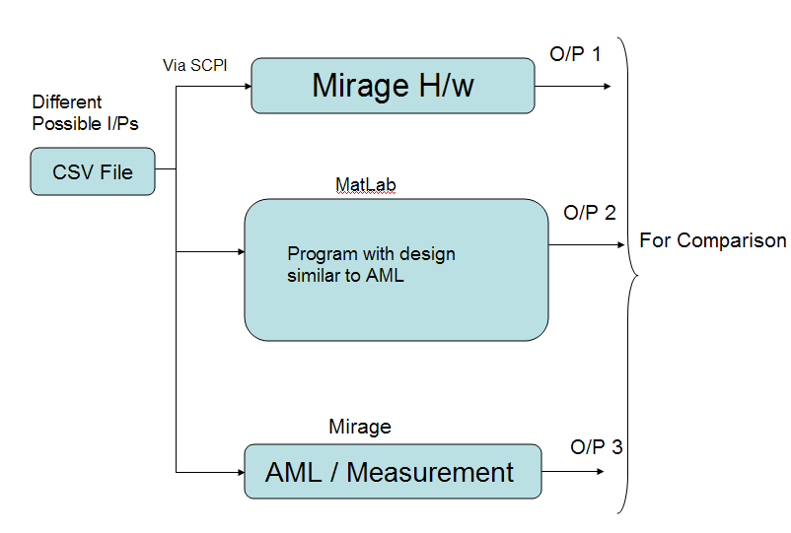

Here we will give same input to Mirage H/W, MatLab Programs and AML-dll and we will compare all three outputs. Mirage H/W will take csv file as an input via SCPI and after performing particular measurement again output will be taken as SCPI. When we will have all three outputs we will compare them and will store the output.

Following rules must be abided while implementing Measurement testing:

- Csv files must be named to the type of wave they contain and total number of datapoints they have, for eg. Sine wave with 64K datapoints: Sine64K.csv and all csv files which are going to act as input for measurement programs must follow naming convention.
- Name of output csv file from every block (AML, Mirage etc) will be:
  - Sine64KOpAML.csv
  - Sine64KOpMLab.csv
  - Sine64KOpMHW.csv
- Name of Result csv file which has come as an output of 2/3 blocks will be Sine64KResult.csv. (If input was Sine64K.csv)
- We must follow folder naming convention i.e. we will have a parent folder Mirage Measurement Testing, inside this we will have three folders with following name:
  - CsvIpSignal: All csv files which are going to act as input will be saved in this folder.
  - CsvOpSignal: All csv files which are coming as output from individual blocks (Mirage H/W, MatLab and AML-dll) will be saved in this folder.
  - CsvResultof2 (Result of comparison of two outputs i.e. MatLab and AML)
  - CsvResultof3 (Result of comparison of three outputs i.e. MatLab, AML-dll and Mirage Hardware ).

